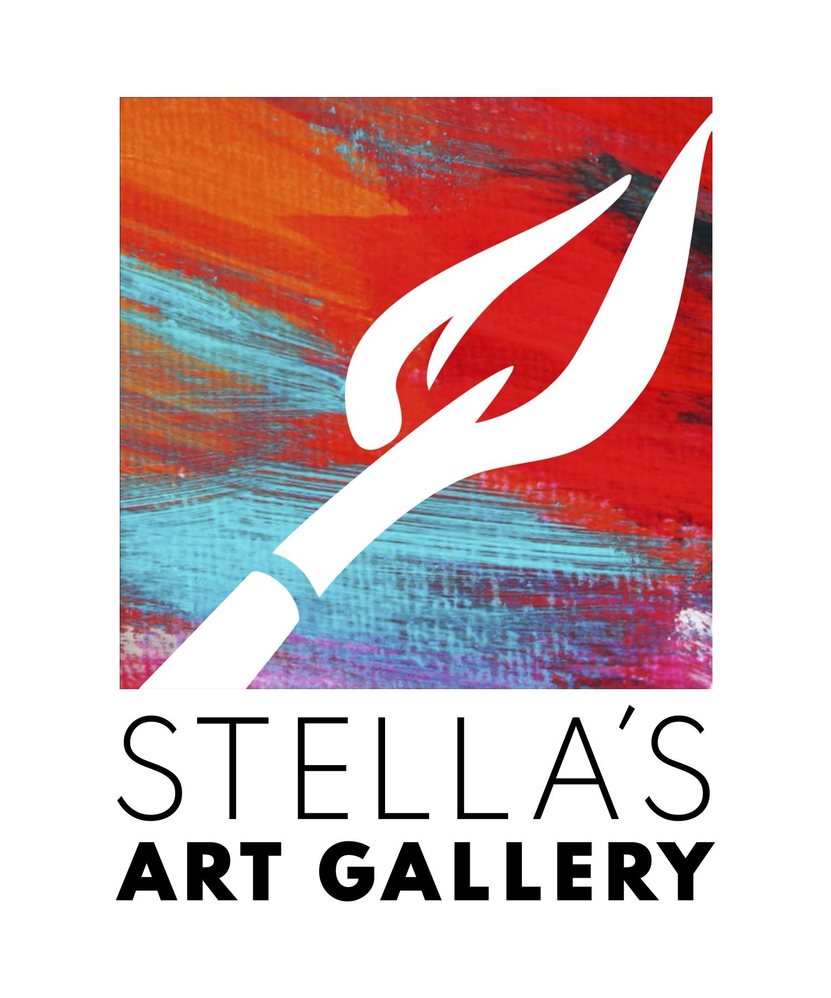
Space: Commemorating the Total Eclipse of the Sun
We are looking for art focusing on outer space. We want to see your interpretation of “Outer Space”.

Stella’s Art Gallery
38033 Euclid Avenue
Willoughby, Ohio 44094
440-266-9111

Artist Name_________________________________________________
Address___________________________________________________________________________________________________________________________________
Phone_____________________________________
Email______________________________________

This is a juried show with Cash prizes and ribbons for First, Second, Third, and Best of Show.

All Mediums Welcome: may include abstract and realistic concepts to define “Space”.
Categories
1. Stars, Northern Lights, Planets & Moons
2. Extraterrestrial, Astronauts, and Pigs in Space (Gen X reference)
3. Space Vehicles and Junk
Juror: Diane Pinchot
Drop off Dates:
April 4th and 5th – 11:30 am to 7:30 pm
April 6th – 11:30 am to 5:30 pm
Fee to enter: 1 for $15, 2 or 3 for $30, 4 for $40, or 5 $50.
Notification of acceptance will be TUESDAY April 9th -NOT MONDAY due to the Eclipse. Unaccepted work must be collected by April 10th 11-7pm. Art will be picked up after the run of the show May 6th 1-6pm.
Reception: April 12th 7-9pm Awards promptly at 8:00.

I Hereby grant permission for my art work to be displayed at Stella’s Art Gallery April 4th- May 6th. I personally assume responsibility for my art work and release Stella’s Art Gallery and it’s employees from loss or damage to my property. Stella’s Art Gallery will take 30% commission on any sold artwork during the run of the show. All artwork must have been created in the last 3 years, not shown in Stella’s Art Gallery before, and ready to be displayed.

Artist Signature:_______________________________________________Date: ___________
Note to artist about TAGS:
Use both sets of provided tags and please print your information. Tag each entry on the front of your artwork when possible and submit the other set of tags with application.
Questions: email Dani Klein at StellasArts@gmail.com
______________________________________________

INTAKE CHECK SHEET (OFFICE ONLY):
Application Form Compete:___________________
Tags: ____________________________________
Wired on Back:_____________________________
Condition: Please note any markings, scatches, and Imperfections on the frame and art: ____________________________________________________________________________________________________________________________________________________________________________________________________________________________________

Office Signature: ______________________________________________________________

Artist  __________________ | Artist  __________________ | Artist  __________________
Medium  __________________ | Medium  __________________ | Medium  __________________
Title  __________________ | Title  __________________ | Title  __________________
Price  __________________ | Price  __________________ | Price  __________________
__________________ | __________________ | __________________

Artist  __________________ | Artist  __________________ | Artist  __________________
Medium  __________________ | Medium  __________________ | Medium  __________________
Title  __________________ | Title  __________________ | Title  __________________
Price  __________________ | Price  __________________ | Price  __________________
__________________ | __________________ | __________________

